Function | SQL Language Syntax
Comment | 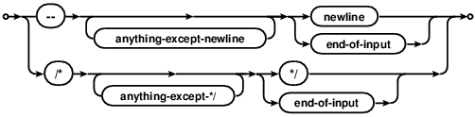
Variable assignment | /* Using the term loosely to mean 'chunk of data, we have this...*/  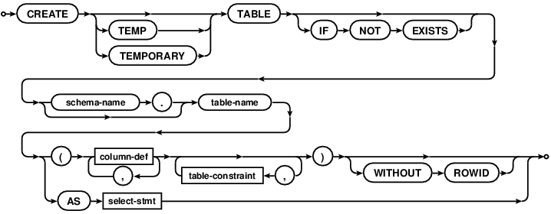  /* to change values, this */  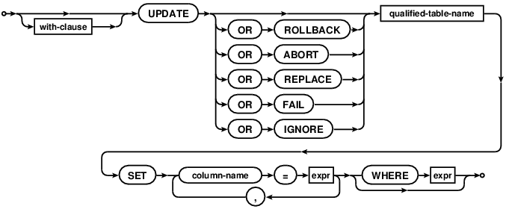  /* to add values, this */  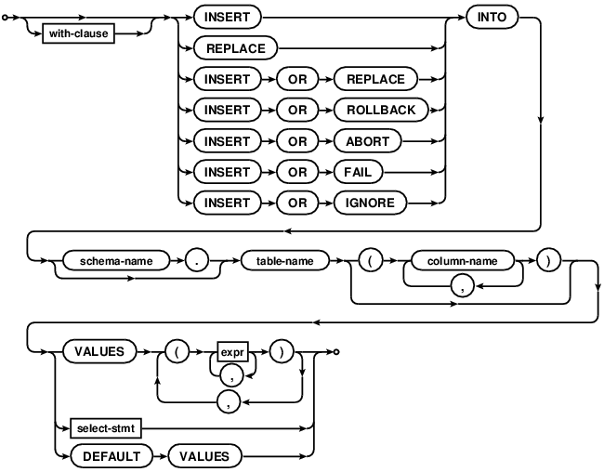  /* to delete values, this */  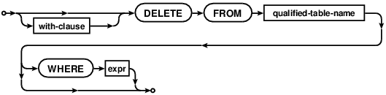
Get help | /* depends on SQL variant. For SQLite it's...*/  .help  /* ...but that's for special commands. In most  cases the way to get help is through Google */
Arithmetic: add, subtract, multiply, divide, exponent, modulo (remainder) | foo + bar  foo - bar  foo * bar  foo / bar  /* No exponent function! But, see this. */  foo % bar;
Controlling order of operations | foo * (bar + baz) / (bat - bax)
Using functions | foo(bar, baz)
Multiple expressions on the same line | foo ; bar; bat;
Logical operators (return TRUE or FALSE): equal, unequal, greater than, less than, greater than or equal, less than or equal | foo == bar; foo = bar;  foo != bar; foo <> bar;  foo > bar;  foo < bar;  foo >= bar;  foo <= bar;
Conditional statements | /* within a select */  CASE WHEN foo=1 THEN 'A' WHEN foo=2 THEN 'B' ELSE 'Z' END  /* when creating a table */  CREATE TABLE IF NOT EXISTS
For loop | /* most closely approximated by a WHERE clause */  WHERE foo=bar;
While loop | N/A /* though there is a RECURSIVE keyword in some SQL variants including the latest SQLite */
Print | select 'foo'; select 3+5;
Plot graphics | N/A  /* SQLiteStudio will probably generate diagrams for you. They will probably be confusing at first. Maybe eventually useful, maybe not. */
Save to a file | .header on  .mode csv  .once foo.csv  SELECT * FROM bar;
Read from file (or clipboard) | .mode csv  .import foo.csv bar;  /* where foo is a .csv file and bar is a table */
Quoting: the character string foo, vs the name foo, vs the value of the foo variable | select 'foo';  select `foo`; select foo;  /* some SQL variants can read a SQL string and interpret it within a stored procedure (this technique is called dynamic SQL). SQLite cannot, depends on some language to pull text out of it and then return it as an executable command */
Create your own function | /* In SQLite this job is done by whatever language is interacting with it (e.g. Java, R, Python, etc.). In other SQL variants this is done by stored procedures. */
Debugging | 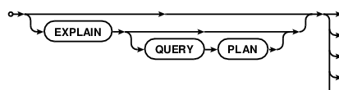
Data structures and subscripting: picking out specific entries within vectors, matrices, lists | 